
G
HY/BIAK/1220/A 18/11/2020
HALF YEARLY EXAMINATION (2020-21)
BIOLOGY - Answer Key
SECTION A
1. | Diabetes, Cancer | 1
2. | G 1. Nucleotide – Phosphate group present 2. Nucleoside-Phosphate absent | 1
3. | Elusion
4. | Inheritance of genes from a male parent to female child and then to male grandchild or female parent to male child and then to female grandchild. 2. E.g., X-linked gene inheritance. | 1
5. | Three – chalazal end, two – central cell. | 1
6. | Packaging of chromatin | 1
7. | Since E. Coli doesn’t have any of antibiotic resistance genes, antibiotic resistance genes are used from outside as select able marker. | 1
8. | Geitonogamous flowers are those where the pollen grain comes from the same plant. The pollen is transferred to the stigma of another flower of the same plant. So it is functionally cross-pollination by involving pollinating agent but genetically it is autogamy (as the plant is same). | 1
9. | Proteases are added to degrade the proteins so that they do not interfere with the downstream DNA treatment. | 1
10. | sporogenous tissue | 1
11. | A OR C | 1
12. | A | 1
13. | D | 1
14. | A | 1
15. | Case study-  Correct Answers:  15i-(d) 15(ii)-c 15(iii)- c 15 (iv)- c 15(v)-c (any 4) | 4
16. | Case study  16(i)-c 16(ii)-c 16(iii)- d 16(iv)-d 16(v)-a (any4) | 4
 | SECTION B
17. | Lymph nodes provide the sites for interaction of lymphocytes with the antigen. When the microorganisms enter the lymph nodes, lymphocytes present there are activated and cause the immune response. | 2
18. | Gi | 2
19. | a) a) Translation- is a process by which the genetic code contained within a messenger RNA (mRNA) molecule is decoded to produce a specific sequence of amino acids in a polypeptide  b) Ribosomal subunits. Site of protein synthesis | 2
20. | a  b. a) PCR-Polymerase Chain Reaction- 1/2  b) b) (1½):  A – Denaturation  B – Annealing  C – Primer extension  OR  A -Plasmid, B-Nucleoid  Plasmid is used as vector to transfer the gene of interest in the host | 2
21. | A = Plumule – To form shoot system B = Cotyledons – Storage of food  OR  1. Flowers are large. 2. Colorful petals of flower.3. Presence of fragrance. 4. Rich in nectar. | 2
22. | a- represents the vein.  b -refers to the epidermis which is the outer layer of the anther.  c- refers to the microsporogenesis tissue which produces the pollen grains by the process of microsporogenesis.  d- refers to tapetum which provides nutrition to the pollen grains.  OR  Mark the following in the picture given below:  a. Hilum b. Funicle c. Nucellus d. Chalazal pole | 2
23. | a. Gel electrophoresis  b. The separated DNA fragments are visualized after staining the DNA with ethidium bromide followed by exposure to UV radiation. The DNA fragments are seen as orange colored bands.  c. DNA fragments of 500bp is separated firstly. Because, the DNA fragments separate out according to their size because of the sieving property of aga rose gel. Hence, the smaller the fragment size, the farther it will move. | 2
24. | Sporopollenin; at germpore sporopollenin is absent. | 2
25. | Cry proteins are a group of toxic protein which are highly poisonous to deficient types of insects. It is produced by soil bacterium Bacillus thuringiensis. The genes controlling their formation are called cry genes eg: - Cry I Ab, Cry I Ac, Cry II Ab, the bacterium produces protein in the crystal form of protoxin. Two cry genes have been incorporated in cotton (Bt cotton) while one has been introduced in corn (Bt corn) As a result Bt Cotton was disease resistance to boll worm and Bt corn was resistance to corn borer. | 2
 | SECTION C
26. | (a) Insertional inactivation (b) β-galactosidase. (c) Selection of recombinants due to inactivation of antibiotics requires simultaneous plating on two plates having different antibiotics. | 3
27. | P  a. a. A is abnormal leading to a disease. (1)  b. b. Mutation in beta chain of haemoglobin at 6th position (1)  c. c. Sickle cell RBCs will not flow easily through the blood vessels and will also not carry as much oxygen, leading to anemia. (1) | 3
28. | (a) EcoRI  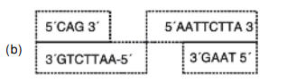  (c) These are named sticky ends, because they form hydrogen bonds with their complementary cut parts. | 3
29. | a. Transfer of pollen grains to the stigma of a pistil is termed pollination.  b. 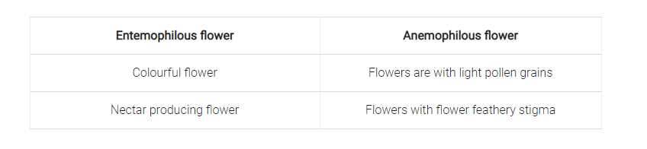  c. In Vallisnaria pollination by water, male flower occur in clusters when mature it detached and reach to the surface of water. The female flower arise singly on long stalk and reaches to the surface of water. Surrounding the female flower, a depression is present in water. It helps the male flower to fall near the female flower resulting in the stamen touching on the stigma surface. | 3
30. | a) The mechanism involved is called insertional inactivation, the phenomenon in which the enzyme becomes inactivated when a recombinant DNA is inserted with in the coding sequence of that enzyme. Steps in process: A recombinant DNA is inserted into the DNA sequence coding for the enzyme galactosidase, it results in the inactivation of the enzyme. In case of the recombinants, when the plasmid has an insert, there is no blue color produced in the presence of a chromogenic substrate in the medium. In the case of nonrecombinants/non- transformants i.e. when the plasmid has no insert, a blue color is produced in the presence of a chromogenic substrate in the medium. (b) Advantage: Simultaneous plating method is quite cumbersome as it requires two plates whereas this method is simple and easy  OR  - a) ori: Ori or origin of replication is a specific portion of plasmid genome that serves as a start signal for self-replication. Any piece of DNA when linked to this sequence can be made to replicate within the host cells. It is also responsible for controlling the copy number of the linked DNA.  b. b) Foreign DNA is inserted into a plasmid by ligating the DNA into a complementary site in the plasmid. These sites are generated by digesting the DNA.  - c) pBR322 plasmid contains three restriction sites: PstI, SalI and ecoRI. The first two restriction sites are located within the gene that codes for ampicillin and tetracycline resistance, respectively. Cleaving at either restriction site will inactivate their respective genes and antibiotic resistance. | 3
 | SECTION D
31. | 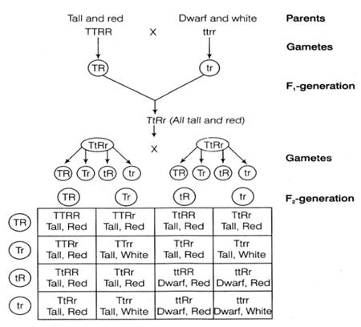  The standard dihybrid ratio observed is 9:3:3:1. If the two genes interact with the values will deviate. This is because when the genes are linked, they do not exhibit independent assortment and remain together in the gametes and the offsprings. The dihybrid ratio thus obtained is 3:1. 2+1+1+1  OR  a) Mendelian disorders are mainly determined by alteration or mutation in the single gene.  Chromosomal disorders caused due to absence or excess or abnormal arrangement of  one or more chromosome. (1+1)  b) A single gene product may produce more than one effect.  For example, starch synthesis in pea seeds is controlled by one gene. It has two alleles  (B and b). Starch is synthesized effectively by BB homozygotes and therefore, large  starch grains are produced. In contrast, bb homozygotes have lesser efficiency in starch  synthesis and produce smaller starch grains. After maturation of the seeds, BB seeds are  round and the bb seeds are wrinkled. Heterozygotes produce round seeds, and so B  seems to be the dominant allele. But, the starch grains produced are of intermediate size in Bb seeds. (1) | 5
32. | a.P-Promoter (½)  b.i. Gene z codes for the enzyme beta-galactosidase.(1)  ii.Gene y codes for beta -permease (a membrane-bound carrier protein).(1)  iii.Gene codes for enzyme beta-galactose transacetylase. (1)  c..If both glucose and lactose are both present, lactose binds to the repressor and prevents it from binding to the operator region. The block of lac gene transcription is thus lifted, and a small amount of mRNA is produced. ... Lactose still prevents the repressor from binding to the operator region. . (1½)  OR  .(i)Genetic code AUG is an initiation codon that works as a start signal and also codes for methionine.  (ii) (a) Genetic codes are universal, i.e. a codon specifies the same amino acid from a virus, to a tree or human being.  (b) The degeneracy of genetic code can be proved by the fact that there are 64 triplet codons, and only 20 amino acids, the incorporation of some amino acids must be influenced by more than one codon with the exception of tryptophan (UGG) and methionine (AUG) that are specified by single codons, while all other amino acids are specified by two to six codons  (iii)Aminoacylation of the fRNA 1*5=5 | 5
33. | (i) ‘D’ Spermatids = undergo spermiogenesis (ii) ‘A’ = Spermatogonium; B = Primary spermatocyte (iii) ‘B’ = Diploid E = Haploid (iv) ‘F’ = Sertoli cells – Nutrition to germ cells (v) Mitosis in Cell ‘A’, Meiosis in cell ‘B  *** | 5

